Feature Importance Report
AnalystLab Africa — Week 3
Selected model: Logistic Regression. Importance method: permutation importance using ROC-AUC on the hold-out test set.
Feature | Importance | Std
MonthlyIncome | 0.06178 | 0.01791
OverTime_Yes | 0.04174 | 0.01063
OverTimeIndicator | 0.04174 | 0.01063
YearsSincePromotion | 0.03518 | 0.01047
MaritalStatus_Single | 0.01503 | 0.00552
StockOptionLevel | 0.01190 | 0.00645
JobInvolvement | 0.01169 | 0.00887
NumberOfCompaniesWorked | 0.00970 | 0.00839
YearsWithCompany | 0.00826 | 0.00378
DistanceFromHome | 0.00596 | 0.00638
TrainingTimesLastYear | 0.00471 | 0.00224
YearsWithCurrManager | 0.00452 | 0.01009
PercentSalaryHike | 0.00295 | 0.00303
EnvironmentSatisfaction | 0.00211 | 0.00394
JobSatisfaction | 0.00202 | 0.00276
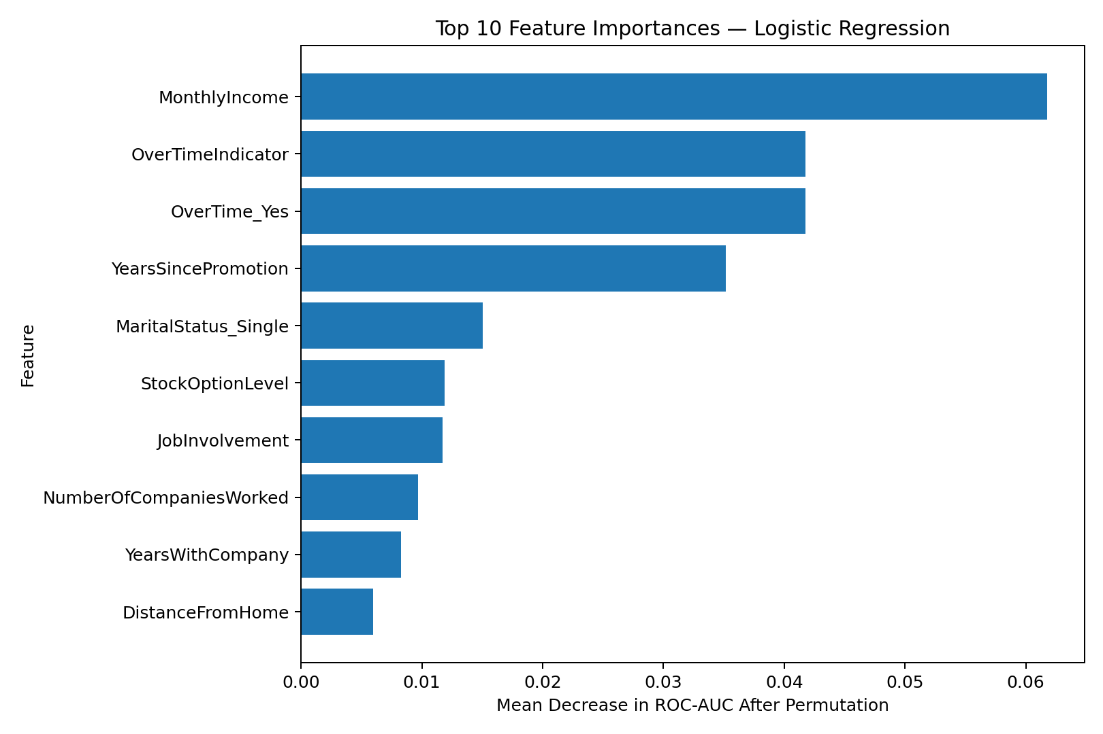
The leading features are useful for prioritising HR analytics attention. However, predictive importance does not establish that changing a feature will directly cause attrition to change.

